June Green Valley Group Exercise Schedule
719 Green Valley Road, Greensboro, NC
The Group Exercise room is located on the first floor. Classes are free for any Cone Health employee and family member!
Monday | Tuesday | Wednesday | Thursday | Friday
Mat Pilates  With Sandy  12:15PM |  |  |  | Restorative Yoga  With Rebecca  12:15 PM
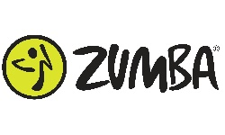  With Yzetta  5:30 PM | 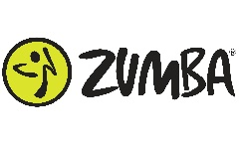  With Yzetta  5:30 PM | 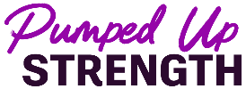  With Sandy  5:30 PM | Cycle  With Sandy  5:30 PM
 | Slow Flow Yoga  With Grayson  6:30 PM | Mat Pilates  With Sandy  6:30 PM | Pump and Sculpt  With Sandy  6:30 PM

Schedule changes and updates are announced on our employee Facebook group. LiveLifeWell at Cone Health | Facebook

Class Descriptions

Mat Pilates: A low-impact workout focused on core strength, flexibility, and posture using controlled movements on a mat.

Slow Flow Yoga: A gentle, mindful yoga class that links breath with slow, continuous movements to build strength and relaxation.

Zumba: A dance fitness class that combines Latin and global music with fun, easy-to-follow choreography.

Pumped Up Strength: A high-energy, full-body resistance training workout that pairs foundational movement patterns with upbeat music. It builds lean muscle and boosts metabolism by using dynamic, rhythmic combinations that work the upper and lower body simultaneously.

Cycle: An indoor cycling class that simulates outdoor riding with varying speeds and resistance for cardio and endurance.

Pump and Sculpt: emphasizes higher repetitions with lighter weights for muscular endurance. Designed to build strength, endurance, and muscle tone while keeping your heart rate up.

Restorative Yoga: A deeply relaxing class that uses props, stretching, and long-held poses to reduce stress and promote recovery.

